# Unit 4 – Lesson 1. Introduction to Database and SQL

**Aim:**

1. What is SQL and what are some of the most commonly used SQL commands?
2. How do we write a simple SQL query to construct a table, query a table and display the result?

**Objectives:** After the lesson, students will be able to:

1. Obtain basic understanding of SQL query and SQL command
2. Use Oracle Live SQL to create simple SQL scripts

**CLASS PROCEDURE:**

***Do Now:***

1. Go to <https://livesql.oracle.com/apex/livesql/file/index.html>. Click “Start Coding” now and log into your account.
2. Once you log into your account, go to “SQL Worksheet” (on the left), and enter the following SQL code:

**begin**

**dbms_output.put_line('hello world');**

**end;**

1. Click “Run” (upper right) to run the SQL script. What is the result?

***Class Discussion / Presentation:***

1. What are the data elements in the PupilPath? What is an efficient way to organize the data?

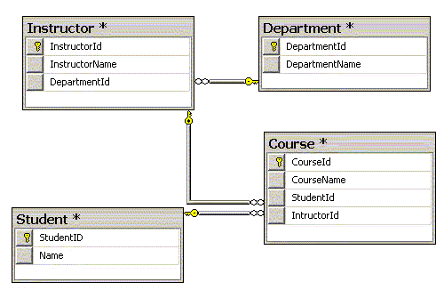

1. We can write SQL script to accomplish the following tasks:

- Create a table and set up or change data type for each field of the table

- Add records to a table or remove records from a table

- Find all of the records in a table match some given conditions

- Join multiple tables, and find records in all of the tables that match given conditions

- Replace records with some other values with given conditions provided

- Save results and rrite results to console or to a report with a given format

Sometimes we can use XML to send the queried data / report to some web front page or some mobile app UI.

1. Go to the Lesson Notes folder, and find a document named “Oracle_PLSQL_Quick_Reference_Card”. Open the document. This document provides you with the most often used SQL commands. You may use the document as references.

***Pair – sharing Activity #1:***

1. Start with a new SQL Worksheet, and enter the following SQL statements to create a table that holds the BxSci department information:

create table dept(

deptno number(2,0),

deptname varchar2(14),

office varchar2(13),

constraint pk_dept primary key (deptno)

)

Run the SQL script. What would happen? What is a primary key? Research online (SQL Developer API or any tutorial), and discuss with your partner.

1. Now, create another table by entering the following SQL statements to the SQL Worksheet:

create table teacher(

empno number(4,0),

teacherlastname varchar2(10),

teacherfirstname varchar2(10),

email varchar2(9),

deptno number(2,0),

constraint pk_teacher primary key (empno),

constraint fk_deptno foreign key (deptno) references dept (deptno)

)

Run the SQL script. What is the difference between a primary key and a foreign key? Research online and discuss with your partner.

1. Let’s insert records into the dept table first:

insert into dept

values (01, 'Math and Computer Science', '107D')

Run the SQL script. What would happen?

Write SQL statements to add Biology, English and Foreign Language departments with department ID 03, 04 and 05. Feel free to add some more departments and you can use the information at the BxSci website as references.

1. Now, how do you add teacher records into the teacher table? Discuss with your partner and add several teachers records for each department into the teacher table.
2. Finally, we want to display all of the teachers with their last name, first name, email, department name, and department office.

select teacherlastname, teacherfirstname, email, deptname, office

from teacher, dept

where teacher.deptno = dept.deptno

order by teacherlastname

Run the SQL script. What results do you see?

1. We can also count the number of teachers in each department, group the teachers by department and display the teachers by descending order:

select deptname, count(*) count_of_teachers

from dept, teacher

where dept.deptno = teacher.deptno

group by DEPTNAME

order by 2 desc

***Pair – sharing Activity #2:***

Write a SQL query script to accomplish the following tasks:

1. Create a STUDENT table with OSIS, LastName, FirstName, Grade
2. Create a CONTACT table with OSIS, Address, Phone, Email
3. Enter at least three records into the STUDENT table (prefer to be your friends in this class)
4. Enter at least three records into the CONTACT table
5. Display OSIS, LastName, FirstName, Grade, Address, Phone and Email, group by Grade and order by LastName descending order

***Challenges:***

1. What if a student has two different addresses in the Address table? How can we display both addresses in the SQL query?
2. Add a 3rd table CLUB with ClubID, ClubName, OSIS, LastName, FirstName. Also insert some records into the CLUB table, and don’t forget – a student can belong to multiple clubs. How do we display all of the following information?

OSIS, LastName, FirstName, Grade, Address, Phone, ClubName